**MINISTRY WORKER HANDBOOK**

Anglican Diocese *of the* Upper Midwest

****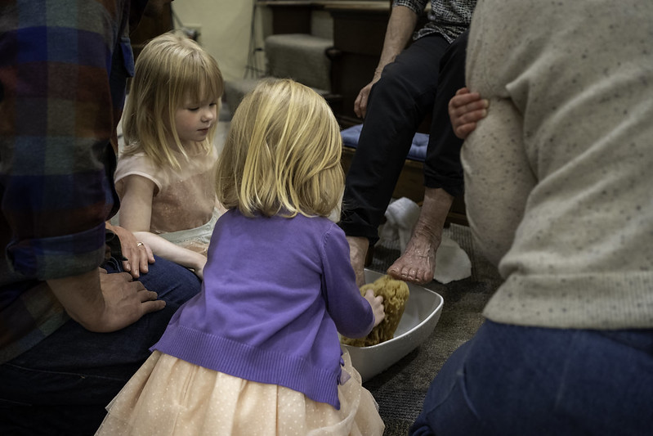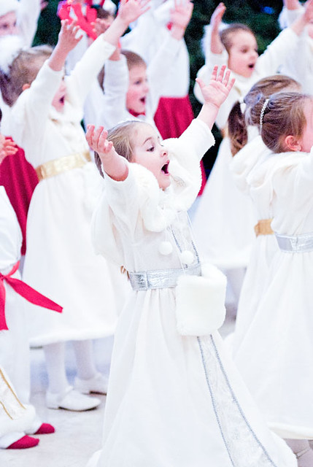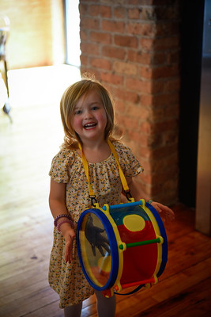****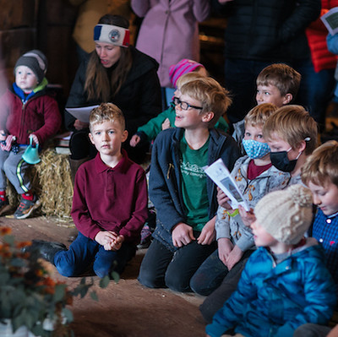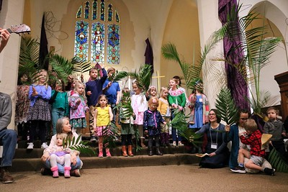

Photos courtesy of Upper Midwest Diocese’s Congregations

THIS PAGE IS INTENTIONALLY BLANK

**Table of Contents**

A. OVERVIEW 1

A.1. Welcome from Bishop Stewart 1

A.2. Definitions 2

A.3. Purpose of this Handbook 3

A.4. Zero Tolerance for Abuse 3

A.5. Five-Point Safety System 3

B. SCREENING AND TRAINING 3

C. INTERACTING 4

C.1. One Adult Never Alone with One Child 4

C.2. Exceptions to the Rule of Three 4

C.3. Physical Interactions with Children 4

C.4. Transportation of Children 5

C.5. First Aid and Medication for Children 5

C.6. Communication with Children 5

C.7. Romantic Relationships 7

C.8. Photography of Children 7

C.9. Gifts to Children 7

C.10. Nudity 7

C.11. Diapering and Restroom Use 7

C.12. Release of Children 8

C.13. Substance Use 9

C.14. Relating Well Regarding Sexuality and Identity 9

C.15. Weapons 9

C.16. Home Groups 9

C.17. Verbal Interactions 9

C.18. Pornography 9

C.19. Spiritual Formation, Spiritual Direction, & Discipleship 10

C.20. Sexual Misconduct 10

C.21. Meetings and Travel 10

C.22. Response to Known Sexual Offenders 11

C.23. Adults in Residential Care Facilities 11

D. MONITORING 11

D.1. Monitoring Procedures for Children 11

D.2. Overnight or Off-Site Events for Children 12

D.3. Adult-Child Ratios 12

D.4. Adult Interactions with Adults 12

E. RESPONDING AND REPORTING 12

F. CONCLUSION 14

G. RESOURCES 14

H. MY AGREEMENT TO THIS HANDBOOK 15

# 

# OVERVIEW

## Welcome from Bishop Stewart

Dear Upper Midwest Diocese,

Our diocesan Congregations and Missions are marked by a love for and commitment to the least and the lost, and to our next generation. This is poignantly displayed in Word and Sacrament ministry happening in congregations and missions throughout the Upper Midwest. While worship and catechesis are forefront, intentional actions, and processes to protect the most vulnerable, are equally important.

Jesus’ prioritization and proper care of the least of these is evident throughout the scriptures, especially so in Matthew 25: 42-45 and Luke 18:15-17. The Upper Midwest *Ministry Worker Handbook* and *Policy for the Protection of Children and Adults*, apply his model of honoring, protecting, and caring for children, youth, and adults to the everyday life of our Diocese.

The Ministry Worker Handbook, in conjunction with the Policy for the Protection of Children and Adults, were developed via the collaborative effort of 2 task forces drawing on such resources as: the UMD Child Protection Policy Standards, the ACNA Sample Policy for the Protection of Children and Adults, and other sources. Once completed both the Handbook and the Protection Policy were approved by the Standing Committee and reviewed by Brotherhood Legal Assist.

We must all be committed to making our Congregations, Missions and Diocese safe places for everyone, but especially for our children, youth and vulnerable adults. If you are a Ministry Worker, i.e. a volunteer, staff person, or clergy who serves with children, youth, or vulnerable adults, within The Anglican Diocese of the Upper Midwest or one of its Congregations or Missions, this handbook is written for you. At the beginning of each ministry year, you will be asked to read and signify your agreement to follow the Ministry Worker Handbook.

Thank you for your commitment to love one another, for partnering with us in making our Congregations, Missions and Diocese welcoming and safe, and especially for your love and care for the children, youth and vulnerable adults you serve in such sacrificial ways.

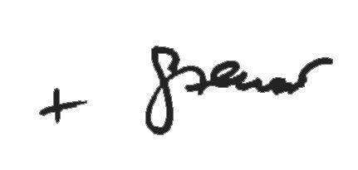

Stewart E. Ruch III

Bishop, Upper Midwest Diocese

## Definitions

*The following are terms used throughout this Policy. They are defined as we, The Upper Midwest Diocese, are using them, which may be nuanced from a dictionary definition.*

**Adult:** Anyone age 18 or older.

**Abuse:** Interactions in which one person behaves in a cruel, violent, demeaning, or invasive manner toward another person which causes or is likely to cause harm or injury. The term encompasses physical, sexual, and emotional mistreatment. Abuse includes Child Abuse.

**Child Abuse:** Any willful act, threatened act, or neglectful act resulting in any physical, sexual, or emotional harm or injury to a Child. In addition, Child Abuse includes “child abuse”, “child neglect,” or similar terms as defined and prohibited by the state in which the activity occurred.

**Bishop:** The Bishop of the Upper Midwest Diocese. In the absence of the Bishop, the entity authorized to act in the absence of the Bishop, such as the Standing Committee.

**Child:** Anyone under the age of 18.

**Children's Pastor:** The person who directs ministry to Children who are not yet old enough to be Youth. This may be a volunteer, employee, or Clergy. If your Congregation has no designated role corresponding to a Children's Pastor, then the Rector is the Children's Pastor. Responsibilities of the Children's Pastor described in this document may be delegated by the Children's Pastor to another individual.

**Clergy:** Ordained ministers active in the Anglican Diocese of the Upper Midwest whether employed or non-stipendiary, whether resident or licensed in the Diocese. (Canonical clergy with an inactive status are not included in this policy’s clergy requirements unless their status changes to active.)

**Congregation:**  A community of worshipers meeting the qualifications of a “congregation” as described in the Upper Midwest Diocese Canons. A “mission” (which includes church plants) as described in the Canons is under the supervision of a Congregation and that Congregation’s policy applies to the mission.

**Diocese:** The Anglican Diocese of the Upper Midwest, also called the Upper Midwest Diocese (UMD).

**Grooming:** Behaviors designed to overcome another person’s defenses by slowly desensitizing their natural reactions to abusive behaviors.

**Intake Officer:** A person who is trained to respond to reports of Abuse and who is designated to receive such reports. An Intake Officer may be contacted at: [midwestanglican.org/reporting-misconduct](https://midwestanglican.org/reporting-misconduct/).

**Ministry Worker:** Any Adult who leads others within the ministry of the Diocese or its Congregations. This includes all volunteers who work with Children or Vulnerable Adults, all volunteers who work in a leadership capacity (e.g., small group leaders, vestry members, etc.), all Clergy, and most employees. Ministry Workers do not include employees or volunteers whose only role is unrelated to work with Children or leading ministry to Adults, e.g. a janitor, a treasurer, a choir member, or a set-up volunteer.

**Rule of Three:** Three not immediately related (spouse, child, or parent) people aged 6 or older, at least one of whom is an Adult,must be present.

**Rule of Two Adults:** Two or more non-dating Adults who are not immediately related (spouse, child, or parent) must be present.

**Vulnerable Adult:** A person who by nature of mental or physical limitations is unable to protect themselves adequately against Abuse. Throughout this document, policies that relate to Children also apply to Vulnerable Adults.

**Youth:** Anyone of age about 12 through 17. The word “Child” includes Youth unless otherwise noted.

**Youth Pastor:** The person who directs ministry to Youth. This may be a volunteer, employee, or Clergy. If your Congregation has no designated role corresponding to Youth Pastor, then the Rector is the Youth Pastor for purposes relating to this document. Responsibilities of the Youth Pastor described in this document may be delegated by the Youth Pastor to another individual. A notification of this delegation must be provided to safeguarding@midwestanglican.org.

## Purpose of this Handbook

This handbook is written for you if you are a Ministry Worker within the Anglican Diocese of the Upper Midwest or one of its Congregations.

This handbook, together with the UMD *Policy for the Protection of Children and Adults,* is intended to make our Congregations and Diocese a safe place for everyone and especially to protect both Children and Adults from Abuse. All Ministry Workers must read and follow this handbook.

## Zero Tolerance for Abuse

The Anglican Diocese of the Upper Midwest has zero tolerance for Abuse (as defined in this policy) in Diocese programs and Congregations. Accordingly, the Diocese strictly prohibits all types of Abuse by any member of the Clergy, and any of its employees or volunteers, and requires its Congregations to strictly prohibit all types of Abuse by the Congregation’s Clergy, vestry members, employees, and volunteers.

## Five-Point Safety System

We use a five-point safety system to prevent misconduct and abuse:

1

Screening

2

Training

3

Interacting

4

Monitoring

5

Responding & Reporting

# SCREENING AND TRAINING

When you became a Ministry Worker you were screened by a background check and possibly by an application and interview. You also received child protection training. This training is renewed periodically. A staff supervisor will contact you when it is time to renew this training.

This handbook provides additional training. You will periodically be asked to agree that you have read and will comply with this handbook.

# INTERACTING

Our personal interactions are the essential place where we provide a safe place for everyone and protect our Children and Adults from Abuse.

## One Adult Never Alone with One Child

Our most important safeguard with respect to Children is to ensure that one Adult is never alone with one Child. When with Children aged five or younger, the **Rule of Two Adults** must be followed.

When working with Children aged six or older, either the **Rule of Two Adults** or the **Rule of Three** must be followed.

Whenever a parent or legal guardian is in the presence of their child, full responsibility for the Child belongs to the parent or legal guardian.

## Exceptions to the Rule of Three

Very limited exceptions to the Rule of Three may be allowed to allow for one-on-one discipleship between a Ministry Worker and a Youth. Such exceptions are allowed only if:

1. The parents or legal guardians have consented to the meeting.
2. The Youth Pastor consents to the interaction and is kept up to date on the interaction.
3. The meeting is in a place visible to other people, never in a private home (unless the parents or guardians approve and are also present in the home) or behind a closed door without a window.

## Physical Interactions with Children

Physical contact must be for the benefit of the Child and never based upon your emotional needs.

**Do not physically discipline Children in any way**. If needed, you may discipline Children using time-outs and other non-physical methods of behavior management. In some circumstances, you or another Ministry Worker may need to physically restrain a Child to prevent self-injury by the Child or harm to others or to property. It is always preferable to distract or remove a Child to a safe place rather than restraining the Child. Report uncontrollable or unusual behavior to the Child’s parent or legal guardian or to your staff supervisor.

**Give physical contact only in observable places.** It is much less likely that touch will be inappropriate or misinterpreted when physical contact is open to observation. Physical contact in any form must not give even the appearance of wrongdoing. Do not force physical contact on a reluctant Child.

**Inappropriate physical contact is forbidden**. Report any inappropriate behavior immediately as described in the Responding and Reporting section below.

Examples of acceptable physical contact include:

* High-fives
* Handshakes
* Fist bumps
* Side hugs
* Pats on the shoulder or back

Examples of inappropriate physical contact include:

* Wrestling
* Tickling
* Kissing

Some types of physical contact are appropriate with Children under the age of five (i.e., sitting on lap or being held or carried in order to comfort) but are not appropriate for older Children.

## Transportation of Children

Ministry Workers sometimes provide transportation for Children to or from ministry events or as part of a ministry event. If you supervise Ministry Workers who provide such transportation, or if you yourself could ever provide such transportation, read and follow the related policies in the UMD *Policy for the Protection of Children and Adults.*

## First Aid and Medication for Children

If possible, medication should be administered by the Child’s parent or legal guardian. Ask your supervisor if you or another appointed Ministry Worker may give medication to a Child. Prescription medication may be given to a Child only if authorized and given written instructions by the parent or legal guardian. Over-the-counter medication may be given by a Ministry Worker according to the instructions on the bottle. The medication must be in the original packaging, including over-the-counter medication.

You may give first aid to a Child without permission from the parent or legal guardian. In a medical emergency you may give necessary medication to a Child without permission from the parent or legal guardian. Notify the Child’s parent or legal guardian and your staff supervisor as soon as possible. If a Child becomes ill or injured during a ministry event, notify the Child’s parent or legal guardian and your staff supervisor as soon as possible.

## Communication with Children

Interact with Children in a way that is encouraging, constructive, and mindful of the mission of aiding parents or legal guardians in the spiritual growth and development of their Children. Do not communicate in a way that could be interpreted as harsh, threatening, intimidating, shaming, derogatory, demeaning, or humiliating. Do not use vulgar language.

Obtain permission from the Children's Pastor or Youth Pastor for any postal (letters, postcards) communication with Children.

**Electronic Communication With Children**

Electronic communication includes phone calls, video calls, email, text messages, social media, etc.

For a Child under twelve years of age, interact with the parent or legal guardian rather than the Child for any electronic communication.

We desire to empower Ministry Workers to engage Youth in meaningful spiritual conversation and encouragement. In our cultural context, Youth are accustomed to relating via electronic methods. Having personal interactions in this venue allows Adults to model appropriate behavior, and it forms valuable connections with Youth.

1. Be aware that your behavior reflects Christ and the church.
2. Relate to Youth as an adult and mentor, not as a peer.
3. Exercise caution regarding the frequency and amount of electronic or written conversation, both for the sake of your personal boundaries and for the Youth's sake. Encourage appropriate face-to-face conversation.
4. Do not disproportionately communicate with an individual Youth unless a pastoral situation calls for it and the Youth Pastor is aware of it.
5. Whenever possible interact with groups rather than individuals.
6. For private conversations, use only email, text messages, and Zoom/Facetime/Google hangouts. Group messaging on other apps is permitted with permission of the Youth Pastor.
7. Do not send private messages to Youth of the opposite sex unless they are of a logistical nature relating to a ministry event (e.g., “Are you able to serve on worship team tonight?”).
8. Do not discuss ANY sexual topic, even if initiated by the Youth. This includes making comments or replies or “likes” to a Youth’s post that contains inappropriate or questionable content.
9. Report to the Youth Pastor any message received from a Youth that has inappropriate content, that indicates the possibility of self-harm or harm to others, or that has other content that concerns you.
10. You must provide any message thread with a Youth to the Youth Pastor or the parent or legal guardian upon request.

We encourage parents or guardians to monitor their Child’s electronic communication and report if they have any discomfort or suspicion regarding a Ministry Worker’s communication.

**Sexually Oriented Communication With Children**

It is expected that periodically youth ministry discussions and lessons may address issues related to dating, sex, and human sexuality. These lessons will convey to Youth the church’s views on these topics. When possible, the Youth Pastor will communicate with parents or legal guardians that this topic will be discussed at an upcoming event.

1. Do not discuss inappropriate or explicit information about your own personal relationships or dating. Never discuss your sexual activities with Children. These behaviors are Grooming, which is forbidden.
2. Do not make comments regarding a Youth’s body that could be interpreted sexually.
3. Youth may have questions/struggles in this area and desire to confide in you for guidance. Proceed with great caution; teach with sensitivity and from a biblical perspective. Consult with the Youth Pastor regarding how to proceed before engaging in such conversations.
4. Do not discuss anything of a sexual nature with Youth in a casual conversation.
5. If a Youth’s questions or comments on a sexual matter become too detailed or explicit, either privately or in a group setting, use discretion and set up another time to meet with the Youth. First consult with the Youth Pastor regarding how to proceed before engaging in the conversation. (The Youth Pastor may wish to have the conversation with the Youth or may want to provide appropriate boundaries.)
6. Report any sexually oriented communications involving a Youth to the Youth Pastor.
7. Employ (subject to limitations imposed the Children’s Pastor or Youth Pastor) age-appropriate materials when leading discussions dealing with human sexuality or sexual abuse prevention.

**Movies, Media, and Music**

Check with the Children’s Pastor or Youth Pastor regarding use of movies, media, and music.

## Romantic Relationships

A romantic relationship between a Child and a Ministry Worker is never appropriate. A Ministry Worker who has a romantic relationship with a Child will immediately be removed from the ministry role that provides interaction with the Child and the appropriate abuse reporting protocols will be followed as described in the Responding and Reporting Section.

Children may develop ‘crushes’ on leaders. Never encourage this.

Remember that a Child is anyone under the age of eighteen. A pertinent example is that an 18-year-old Ministry Worker dating a 17-year-old Child is prohibited.

## Photography of Children

Photograph a Child only if you have permission from your staff supervisor.

## Gifts to Children

You may provide a gift to a Child if:

1. The gift is for special times such as Easter or Christmas and substantially similar gifts are given to a group of Children, or
2. The gift marks a special occasion in the life of the Child such as confirmation or graduation and permission is obtained from the Child’s parent, Children's Pastor or Youth Pastor.

Never provide a gift simply to endear yourself to a Child or to seek a personal relationship with a Child. Such gift giving could be a form of Grooming.

## Nudity

Nudity is strictly prohibited. If applicable, procedures for showering or changing clothes must be provided so that participants (both Ministry Workers and Children) are never nude in sight of one another.

## Diapering and Restroom Use

**Diapering Children**

1. We strongly prefer that only the Child’s parent or legal guardian diaper a Child.
2. If a Ministry Worker is allowed to diaper a Child, only a female Ministry Worker in full view of another Ministry Worker may do so. (The limitation to females builds trust and minimizes exposure based on statistical research—the vast majority of Child Abuse is perpetrated by males.)
3. Do not leave a Child unattended while being changed.
4. Re-diaper and re-clothe the Child immediately.

**Helping Young Children Use the Restroom**

1. Allow a Child who is capable to use the restroom without aid.
2. Do not leave a child aged three and under unattended in the restroom. Have them leave the door ajar with a Ministry Worker standing outside the door, facing away from the restroom.
3. If a child needs assistance in a restroom, only a female Ministry Worker may assist with another Ministry Worker in sight of the partially open door.
4. Do not allow a Child to be in a restroom alone with an Adult. For shared or public restroom settings accompany the Child to and from the restroom and enter the restroom to ensure it is unoccupied before the Child enters it. Wait outside the restroom and ensure that no one else enters the restroom until the Child leaves the restroom.
5. Assist a Child in straightening their clothing before returning to the room with other Children, if necessary.
6. Handle accidents by reassuring the Child and notifying the parent or legal guardian that a change of clothing is needed.

**Restroom Use for Elementary Age Children**

1. Elementary-age Children may be accompanied to the restroom for supervision and assistance when needed. Give the minimum amount of assistance needed based upon a Child’s individual capabilities. Triads of the same-aged/biological sex (a buddy system) may be used.
2. Do not be alone with a Child in a restroom.
3. Do not allow a Child to be in a restroom alone with an Adult. For shared or public restroom settings accompany Children to and from the restroom and enter the restroom to ensure it is unoccupied before any Child enters it. Wait outside the restroom and ensure that no one else enters the restroom until the Child leaves the restroom.

**Restroom Use for Youth**

1. Be aware if a Youth repeatedly leaves to use the restroom and stays there for unusual periods of time. Report this behavior to your staff supervisor.
2. In public contexts, when possible, send Youth to use the restroom in groups of at least three.

## Release of Children

Release Children in your care only to parents or legal guardians or someone designated by parents or legal guardians. It is presumed that a person who drops off a Child has authority to pick up the Child. If you are uncertain of the propriety of releasing a Child contact your supervisor before releasing the Child.

## Substance Use

Do not use, possess, or be under the influence of tobacco, alcohol, or any illegal drugs in the ministry context. Do not abuse prescription drugs. Do not supply a Child with tobacco, alcohol, or any illegal drugs or enable a Child to abuse prescription drugs. Such behaviors will result in dismissal or disciplinary action for Clergy or employees or removal from volunteer ministry for volunteers. If you struggle with an addiction talk to your pastor or find a local resource on your own.

## Relating Well Regarding Sexuality and Identity

To provide pastoral ministry to those facing same-sex attraction or who identify themselves as transgender: treat all people as created in the image of God. We strive to build an environment that does not harass, discriminate, intimidate, or devalue God’s creation, while also holding to biblical sexual morality. Make sure no one feels isolated, but rather that everyone feels included, welcomed, valued, and respected. Provide ongoing and open communication with parents or legal guardians who have child-specific concerns. If you have concerns about how to interact with a specific Child related to sexuality, talk with your staff supervisor.

## Weapons

Do not carry a weapon and do not have a weapon in any location potentially accessible to a Child while serving with Children.

## Home Groups

If you are the leader of a ministry group that meets in a home that may have Children present, consult with your staff supervisor.

## Verbal Interactions

**(This section and subsequent sections apply to all ages.)**

Use verbal interactions to encourage and respect others. Use personal interactions (whether face-to-face, on social media, or any other method of communicating) to model appropriate behavior and language. Refrain from inappropriate topics. Be aware that your behavior reflects Christ and the church. Specifically, the following are forbidden:

1. **Intimidation:** behavior directed toward an individual with the intention of causing fear, including forcing someone to do something they do not want to do.
2. **Harassment:** use of words, gestures, material, or electronic communication that shows hostility toward an individual or that is sexually explicit or intended to offend.
3. **Misuse of spiritual authority:** using spiritual authority to influence or attempt to influence another person into relationships, attitudes, or behaviors that are unbiblical.

## Pornography

Do not create, view, or distribute pornography. If you struggle with pornography, talk to your pastor. If you cannot talk to your pastor, find a local resource or reach out to Reverend Dr. Sam Pascoe (703-256-3442) ([www.sampascoe.com](http://www.sampascoe.com/)) for a confidential referral.

Intentionally exposing a Child to pornography is Child Abuse and the appropriate abuse reporting protocols must immediately be followed as described in the Responding and Reporting Section.

## Spiritual Formation, Spiritual Direction, & Discipleship

Church-sponsored Christian discipleship often occurs in the context of one-on-one or small group relationships where participants meet regularly for a long-term partnership. Such groups may include Adult-only groups, groups of Youth led by an Adult, or perhaps even Youth-only groups if allowed by the Youth Pastor. Regardless of age, such groups must avoid the appearance of or potential for inappropriate relationships:

1. Ensure this relationship is brought into the light among the leadership team of the church by informing multiple leaders of the relationship.
2. If this relationship includes Youth meeting in a home, a minimum of two adults must be present. Read and follow the related policies for off-site gatherings in the UMD *Policy for the Protection of Children and Adults.*

## Sexual Misconduct

Sexual misconduct is not permitted. It is a form of Abuse. Sexual misconduct can victimize individuals of any age. Sexual misconduct includes any behavior outside of biblical sexual standards as well as a wide variety of behaviors including but not limited to:

**Grooming**: behaviors designed to overcome another person’s defenses by slowly desensitizing their natural reactions to abusive behaviors.

**Sexual abuse:** inappropriate sexual contact or interaction. Sexual abuse includes sexual assault, exploitation, molestation or injury, and all forms of sexual violence.

**Sexual coercion:** the use of physical or emotional power to gain sexual gratification.

**Sexual harassment:** unwelcome conduct or communication of a sexual nature including repeated requests for social engagements.

**Inappropriate emotional intimacy:** a non-sexual relationship involving a similar level of emotional intimacy and bonding as a romantic relationship.

## Meetings and Travel

For meetings and travel arrangements related to your role as a Ministry Worker, avoid any appearance of inappropriate relationships.

**Meetings**

* For one-on-one meetings of Ministry Workers with each other,meet somewhere that other people are present, e.g., a church office, a coffee shop, etc., even for meetings where both participants are of the same sex.
* A male and female may not be alone together in an office or other room unless they are visible to others outside the room (e.g., via an open door or a window in the door).
* For meetings off-site between a male and female:
* Let your supervisor know the meeting is taking place, including the time and place.
* Meet in a public space where other people are present.
* Inform your spouse if married.

**Travel**

Regarding travel to overnight events:

* Do not be alone together (e.g., in a car) with an unrelated person of the opposite sex.
* Unrelated people of the opposite sex must book separate, non-adjoining rooms for lodging.
* Inform your spouse if married.

## Response to Known Sexual Offenders

If you become aware of a known sexual offender attending the church or involved in a ministry activity, immediately notify the Rector and Sr. Warden.

Special care must be taken when a Congregation interacts with a person who is registered as a sexual offender or self-discloses a history of sexual misconduct. Refer to the UMD *Registered Sexual Offender Policy*.

## Adults in Residential Care Facilities

If you minister in a residential care facility (e.g., a nursing home, assisted living residence, or group home) consult with your staff supervisor.

# MONITORING

Monitoring helps detect problems before they turn into Abuse and helps avoid wrongful allegations of Abuse where none has occurred.

Watch for Abuse and report it as described in the “Responding and Reporting” section below. Policy violations that do not rise to the level of Abuse should be reported to your supervisor and to the independent Intake Officer.

## Monitoring Procedures for Children

1. Keep Children in supervised areas within the building during a ministry activity.
2. Keep unused rooms locked whenever possible.
3. Keep interactions with Children in full view of others.
4. Never leave a Child unattended during a ministry activity.
5. After a ministry activity, ensure that no Child remains in the building. This may be by means of physically checking each unlocked room, by a check-in/check-out system, or by some other system of accounting for every Child who was present. For physical room checks follow the Rule of Two Adults or the Rule of Three to prevent a situation where one Adult could be alone with one Child who remained behind.
6. Invite parents or legal guardians to visit at any time unannounced. (If a parent or legal guardian is a known abuser this does not apply. If a parent or legal guardian visits repeatedly the parent or legal guardian should go through the same screening and training required of Ministry Workers.)
7. Watch for violations of this handbook.

## Overnight or Off-Site Events for Children

If you are helping with an off-site or overnight event read and follow the relevant sections in the UMD *Policy for the Protection of Children and Adults*.

## Adult-Child Ratios

Each Congregation must meet any state mandated adult-child ratios. The following are the minimum recommended ratios of Ministry Workers to Children, based on MinistrySafe standards. For meeting adult-child ratios, a Youth helper who meets the requirements described in the “Youth Helper Policy” of the *Policy for the Protection of Children and Adults* may substitute for one of the Adults, if allowed by the state. The Rule of Two Adults or the Rule of Three must still be met.

* 1. Infants: 2 Adults for up to 8 Children
  2. Young toddlers: 2 Adults for up to 12 Children
  3. Two and three years: 2 Adults for up to 16 Children
  4. Four years: 2 Adults for up to 20 Children
  5. School age: 2 Adults for up to 40 Children
  6. Mixed age group: ratio for the youngest Child in the group

## Adult Interactions with Adults

If you see one Adult mistreating another Adult, report it as described in the “Responding and Reporting” section below. Including more than one leader in the discussion encourages accountability, transparency, and appropriate resolution. Do not assume that because others saw it, even if they are of a higher supervisory position than you, that they will report it. Do not assume that if the target of the misconduct says nothing that it should not be reported by you. If you believe misconduct occurred, report it.

# RESPONDING AND REPORTING

The moment someone reports a possibility of Abuse to you **your primary responsibility is to provide a safe environment for the person who may have been abused**. If possible, ask your staff supervisor or another Ministry Worker to join in listening to the account. If someone begins a conversation implying that they are about to disclose Abuse and asks you to keep it a secret, remind them that your primary job is to keep them safe and sometimes that means getting help and for that reason you cannot promise you will keep it secret. If someone reports Abuse, it is not your responsibility to investigate or verify; you should report to the proper authorities who will investigate.

Use the diagrams below to understand how to respond and report.

Someone just disclosed abuse to me, HOW SHOULD I RESPOND?

**SAY**

**DO:**

Be compassionate! Listen. Stay calm.

“I hear you and I take this seriously.”

“I’m very concerned about what you just said and want to make sure you are safe.”

“Thank you for being brave enough to share this with me.”

**DON’T:**

Express judgment, doubt, or disbelief.

**ACT**

**DO:**

If necessary, help the person find safety.

Report as shown in the next diagram.

Make notes of the conversation and actions taken.

**DON’T:**

Tell anyone who does not need to know.

**ASK**

**DO:**

Ask open-ended questions that give the person the opportunity to share without influencing his/her account.

Find out if he/she is safe.

Determine who, what, when, where, if possible, without probing.

**DON’T:**

Probe or ask for details.

Push the person to tell you more than he/she is comfortable with.

Someone just disclosed abuse to me. WHO SHOULD I REPORT TO?

If the complaint is regarding Abuse of a Child or Vulnerable Adult: immediately report to state authorities (see Resources section) in accordance with applicable law and legal privilege.

If the complaint is against a bishop:

Report to the province at:

[misconduct@acna.org](mailto:misconduct@acna.org)

If the complaint is against anyone other than a bishop:

Report to our independent Intake Officer:

[midwestanglican.org/reporting-misconduct](http://midwestanglican.org/reporting-misconduct)

Report to an additional senior leader of your congregation (such as the Rector, Sr. Warden Children’s Pastor, or Youth Pastor) as determined by your context.

A report of possible abuse does not equate to an accusation, condemnation, or conviction of the persons involved.

# CONCLUSION

Thank you for reading this handbook. Our goal is to make our churches and Diocese safe for everyone. Your careful following of this handbook helps make that possible.

# RESOURCES

**Diocese of the Upper Midwest**

* **Intake Officer:** [midwestanglican.org/reporting-misconduct/](https://midwestanglican.org/reporting-misconduct/)
* ***Policy for the Protection of Children and Adults***

**Mandated Report Links:**

* + - For assistance in reporting, call the Childhelp National Child Abuse Hotline: (1-800) 422-4453
    - **Illinois:** [www2.illinois.gov/dcfs/safekids/reporting/Pages/index.aspx](https://www2.illinois.gov/dcfs/safekids/reporting/Pages/index.aspx)
    - **Iowa:** (1-800) 362-2178
    - **Minnesota:** [mn.gov/dhs/people-we-serve/children-and-families/services/child-protection/contact-us/](https://mn.gov/dhs/people-we-serve/children-and-families/services/child-protection/contact-us/)
    - **Missouri:** [dss.mo.gov/cd/keeping-kids-safe/can.htm](https://dss.mo.gov/cd/keeping-kids-safe/can.htm)
    - **South Dakota:** [dss.sd.gov/childprotection/](https://dss.sd.gov/childprotection/)
    - **Wisconsin:** [dcf.wisconsin.gov/reportabuse](https://dcf.wisconsin.gov/reportabuse)

**Mandated Reporter Resources/Guides/Manuals:**

* **All States:** [How to Report Child Abuse and Neglect](https://www.childwelfare.gov/how-report-child-abuse-and-neglect/)
* **Illinois**: [Manual for Mandated Reporters](https://mr.dcfstraining.org/UserAuth/Login!loginPage.action)
* **Iowa:** [Mandatory Reporter Training](https://educate.iowa.gov/educator-licensure/mandatory-reporter-training)
* **Minnesota**: [Resource Guide for Mandated Reporter of Child Maltreatment Concerns](https://edocs.dhs.state.mn.us/lfserver/Public/DHS-2917-ENG)
* **Missouri:** [Guidelines for Mandated Reporters of Child Abuse and Neglect](https://dss.mo.gov/cd/pdf/guidelines_can_reports.pdf)
* **South Dakota:** [Mandatory Reporter Training](https://sdcpcm.com/our-work/mandatory-reporting/)
* **Wisconsin:** [Mandated Child Abuse and Neglect Reporters | Wisconsin Department of Children and Families](https://dcf.wisconsin.gov/cps/mandatedreporters)

# MY AGREEMENT TO THIS HANDBOOK

IF YOU ARE A CHURCH MINISTRY WORKER COMPLETING THIS AGREEMENT FOR A CONGREGATION

Name: _________________________________

I agree that I have read, understand, and will follow the UMD *Ministry Worker Handbook*.

I understand that the handbook may be modified at any time, and that my agreement to the modified handbook will be required at that time to continue as a Ministry Worker.

For employees or clergy: I understand that violation of this handbook could be grounds for immediate dismissal or disciplinary action.

For volunteers: I understand that violation of this handbook could be grounds for immediate removal from volunteer ministry.

Signature: __________________________________ Date: ________________

Non-clergy Ministry Workers associated with a specific Congregation: return this signed form to the person designated in your Congregation to receive this form.

AGREEMENT FOR THE DIOCESE

If you are a clergy person, diocesan staff, Standing Committee Member, diocesan Supervisor or Ministry Worker (as defined in this Handbook), click this LINK to complete your adherence form.